
Table of Contents
Rules Engine as a Service 2
Key Features 2
Supported Ingress and Egress Data Sources 3
Structured Rule Authoring Workflow 4
File System Configuration Management Example 7
Source and Destination System to Pull the Data and Where to send the results 8
Rule Space and Rule Group Set Up Details 9
Triggering the Rule Execution By Passing the Execution Props and DB Connector Props 10

Rules Engine as a Service
A robust and scalable rules engine delivered as a service, designed to simplify and accelerate decision automation.
- Robust Configuration Management
Rules engine metadata and setup information are stored in a configuration management system, which interfaces with a persistent layer such as a file system, SQL database, NoSQL store, or cache
- Multi-Channel Interfaces
Interact with the Rules Engine via a user-friendly UI, RESTful APIs, declarative PraeSQL (pseudo-SQL), and XLS import for bulk rule ingestion—enabling both technical and business users to configure and manage rules efficiently.
- Generative AI Integration
Extend rule creation, optimization, and testing with Generative AI tools—enabling automated rule suggestions, natural language inputs, and intelligent validation to accelerate decision logic design.

Key Features
- Hybrid Deployment Ready
Deploy seamlessly across cloud and on-premises environments for maximum flexibility. Available as a Docker image, standalone microservice, or scheduled batch job.
- Performance Efficiency
Platform has been load tested successfully, processing 100,000 records in just 1.5 minutes, equating to an average processing time of 1 millisecond per record and a throughput of approximately 1,000 records per second.
- Multi-Source Data Orchestration
Efficiently orchestrate data ingestion from diverse and distributed sources.
- Language-Agnostic Integration
Compatible with all major programming languages for seamless embedding into existing tech stacks.
- Flexible Data Source Connectivity
Easily integrates with various structured and unstructured data sources.
- Configurable Data Transformation
Supports rule-driven parsing, formatting, and enrichment of data without hardcoding logic.
- Built-in Observability & Reliability
Native support for monitoring, retries, and replay ensures reliable and transparent operations.
- Scalable & Resilient Architecture
Designed for high availability and horizontal scalability to meet enterprise-grade demands.
- End-to-End Data Security
Secure "onion-layered" encryption for data in transit and at rest, ensuring compliance and trust.

Supported Ingress and Egress Data Sources
Praecepta Rules Engine as a Service offers seamless integration with a wide range of data exchange endpoints for both ingestion and output:
Message Brokers
- Apache Kafka – High-throughput distributed messaging
- ActiveMQ – Lightweight, open-source message broker
- IBM WebSphere MQ – Enterprise-grade messaging platform
SQL Databases
- Oracle – Enterprise-grade relational database
- MySQL – Open-source relational database
- H2 – Lightweight in-memory database
- PostgreSQL – Advanced open-source RDBMS
NoSQL Databases
- Cassandra – Distributed, highly scalable NoSQL DB
- Elasticsearch – Real-time search and analytics engine
- MongoDB – Document-oriented NoSQL database
File Systems
- Unix & Windows File Systems – Supports file ingestion/export from both environments
HTTP Clients
- Native support for data ingestion and delivery via RESTful HTTP clients
AI-Integrated Data Flow
- Seamlessly ingest AI-generated or AI-processed data into the Rules Engine to drive intelligent decisioning.
- Post-execution, route Rules Engine outputs to AI models for advanced processing such as summarization, classification, enrichment, or insight generation—enabling a closed-loop intelligent automation pipeline.

Structured Rule Authoring Workflow

Rule creation follows a two-step model:
- Spaces – Logical containers to organize rules by domain, function, or business context.
- Rule Groups – Within each Space, define rule groups with support for deeply nested conditions to express complex decision logic with precision and clarity.
Create Rule Space:
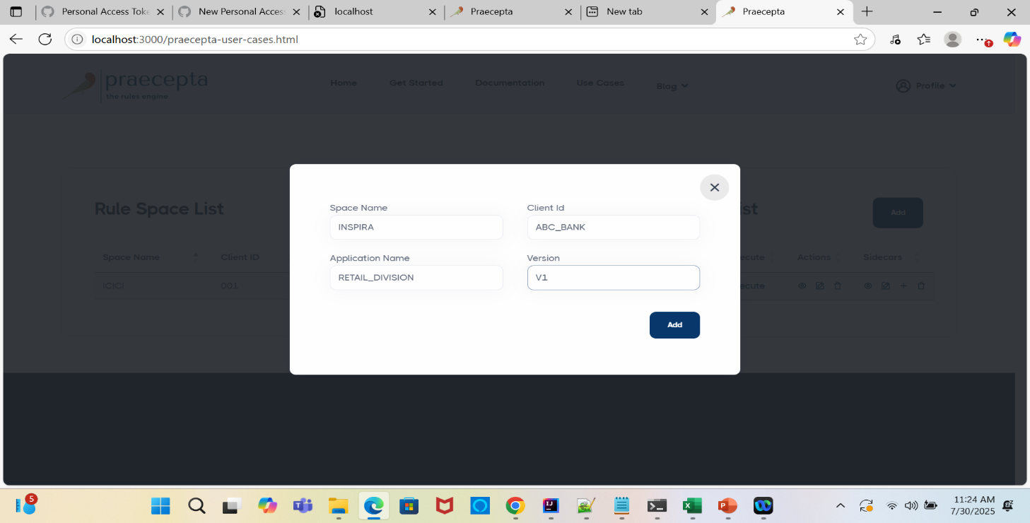
Rule Space List:
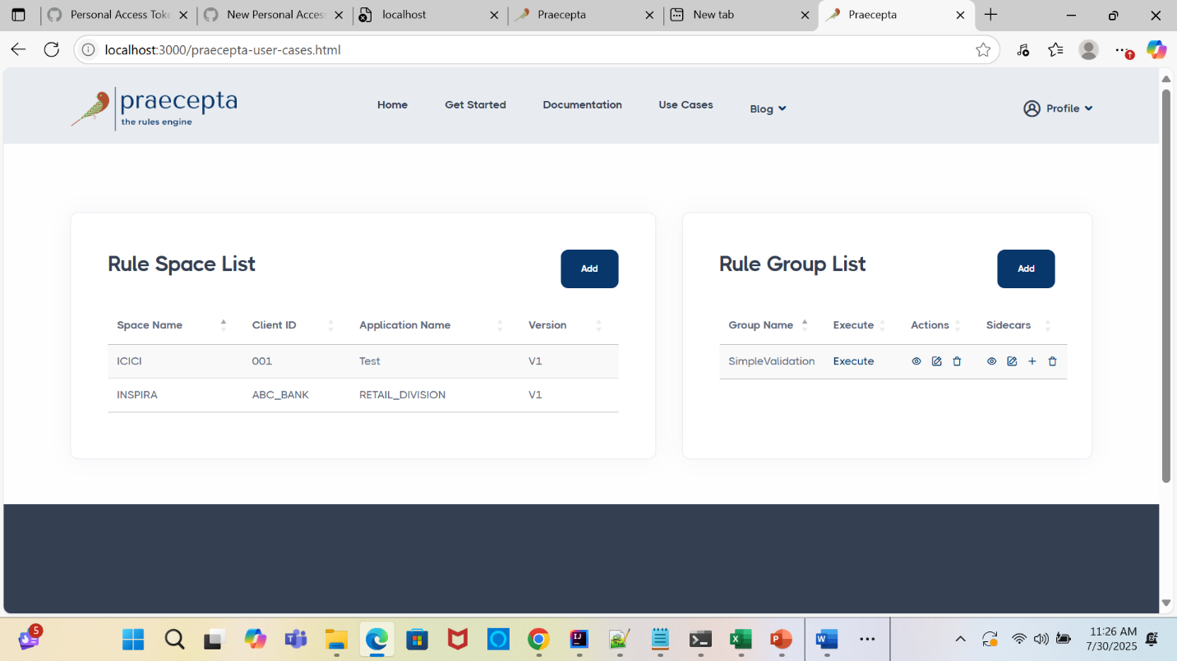

Create Rule Group:

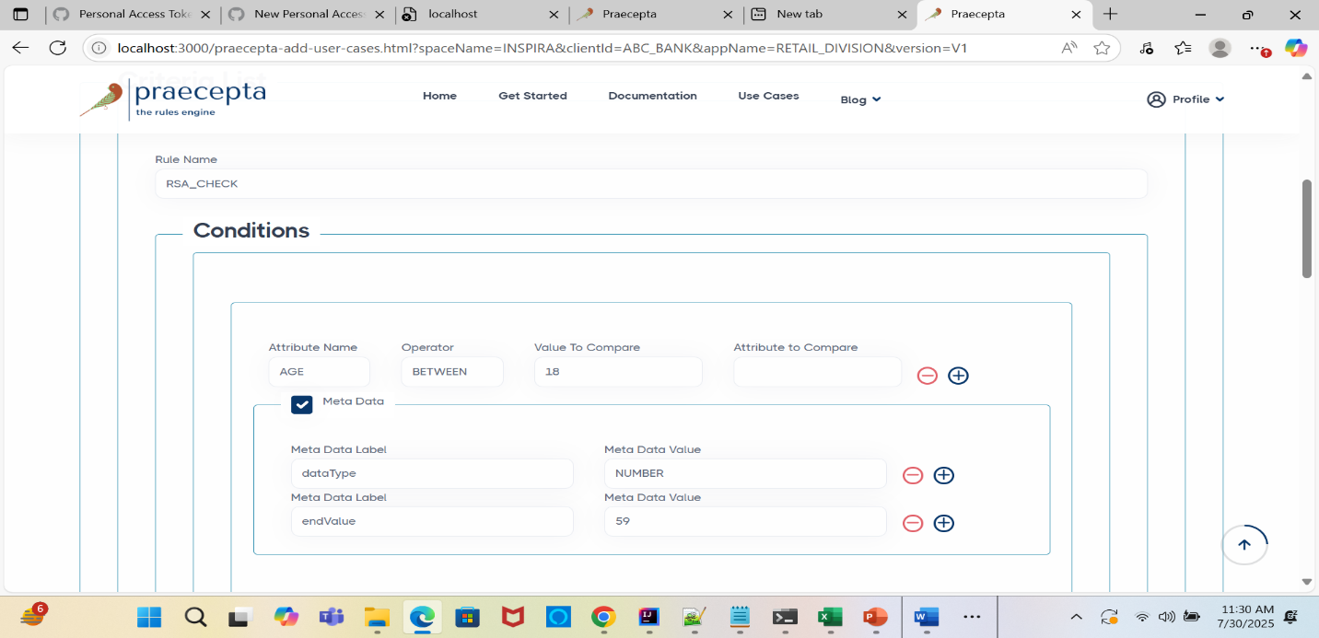

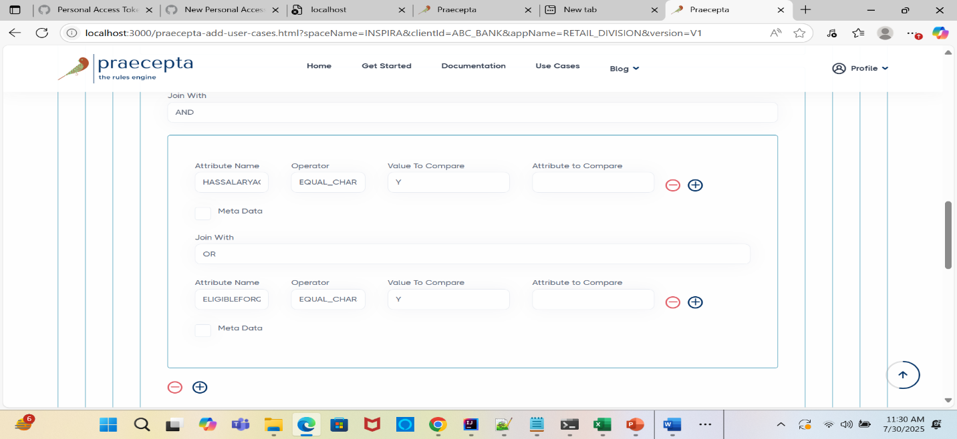

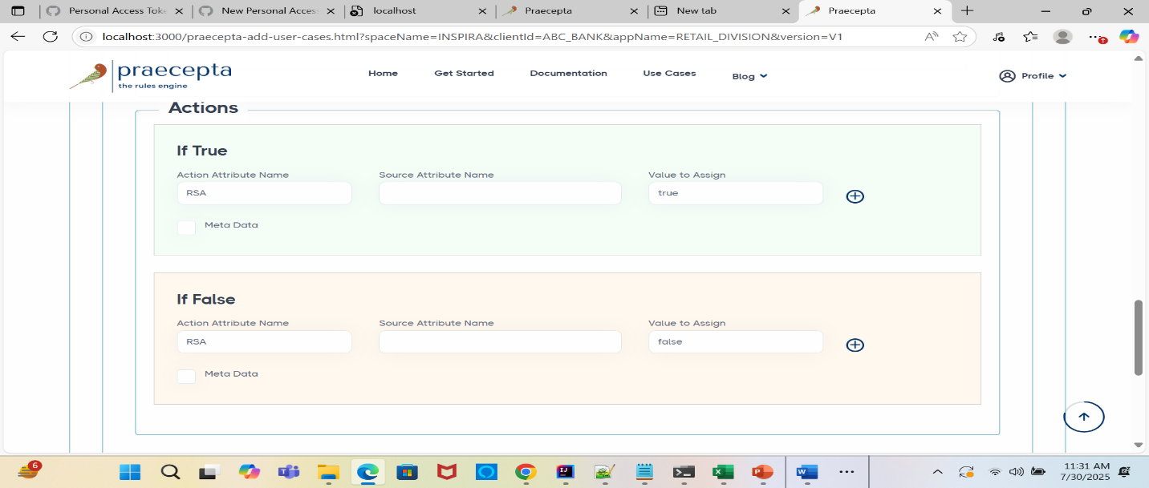
Creating second Rule:
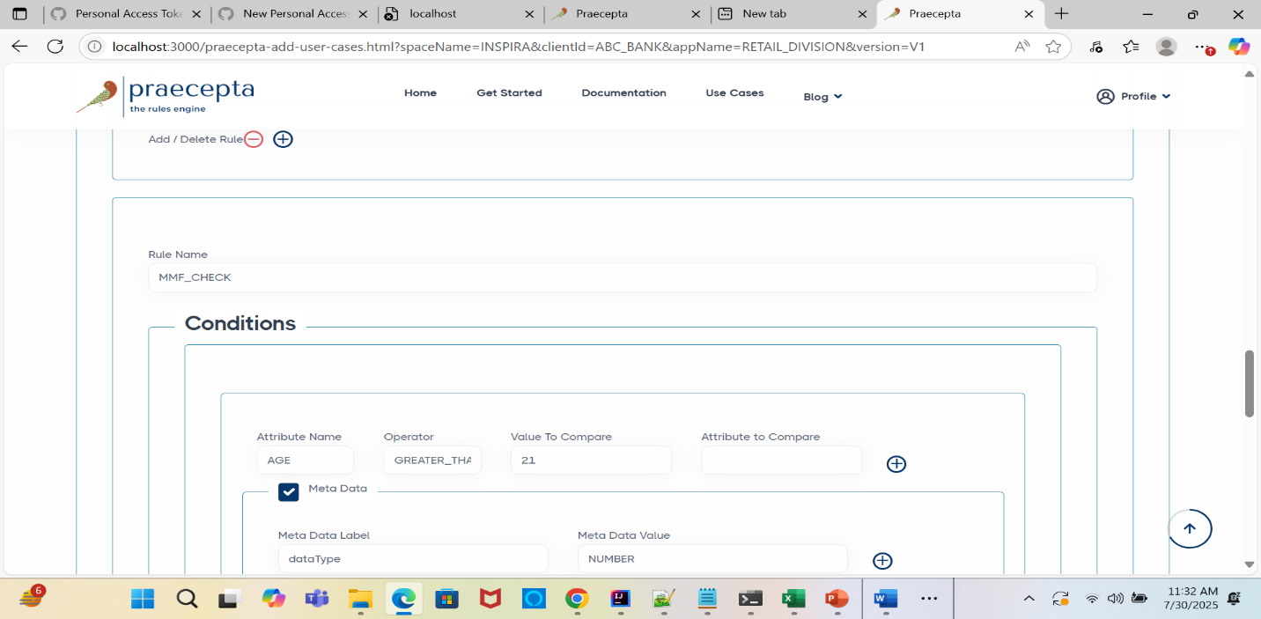

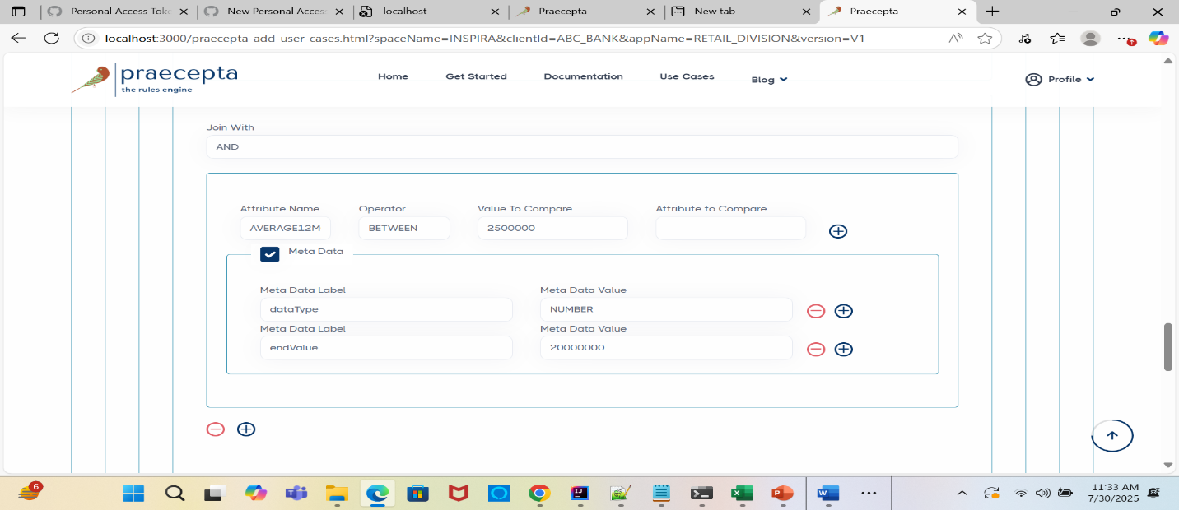

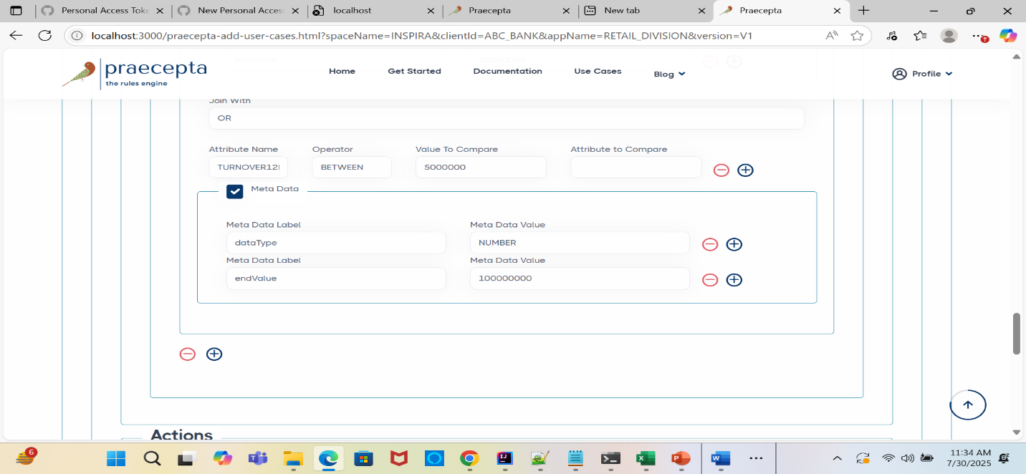
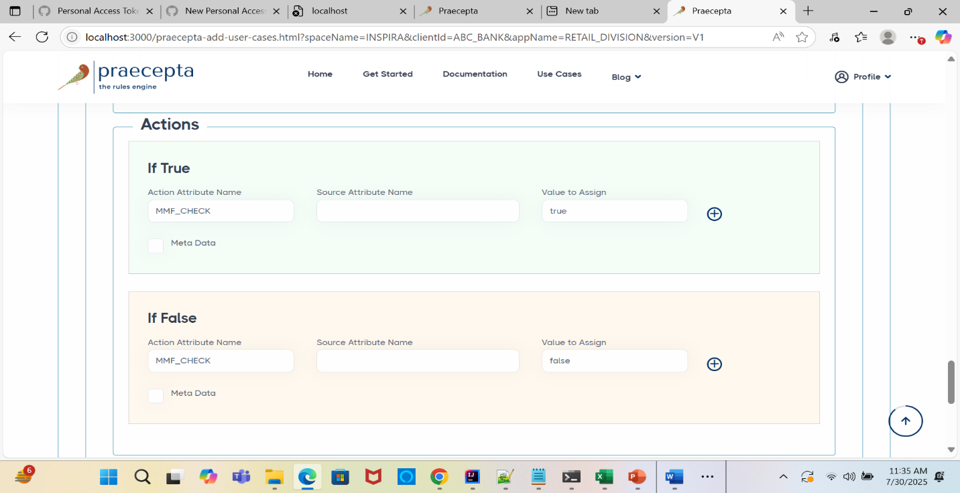

File System Configuration Management Example

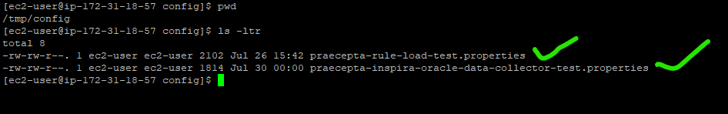
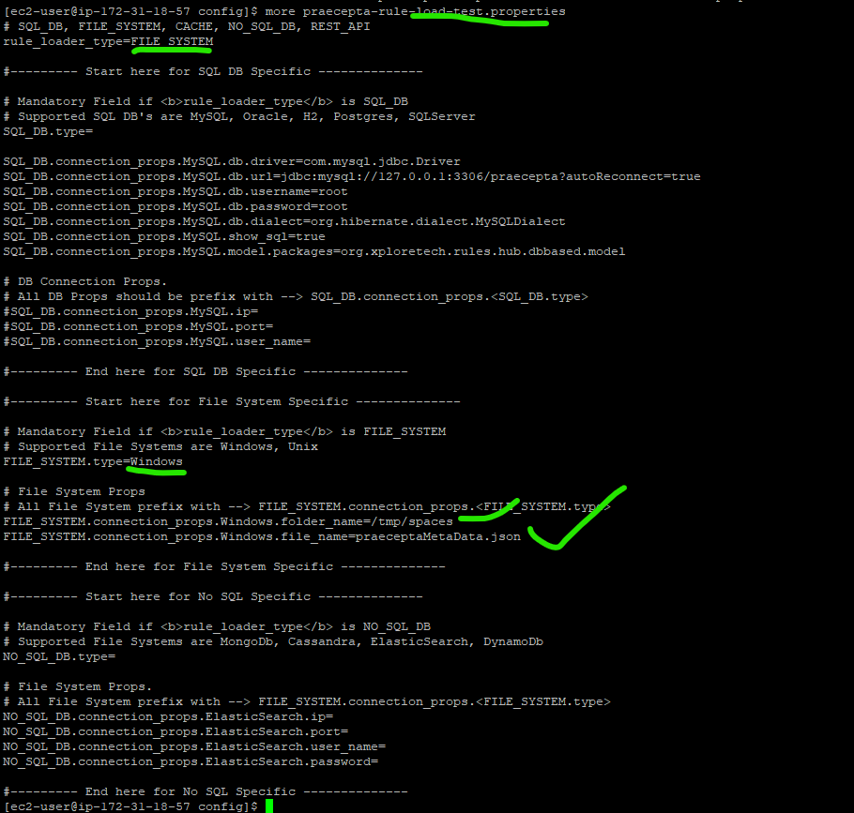

Source and Destination System to Pull the Data and Where to send the results
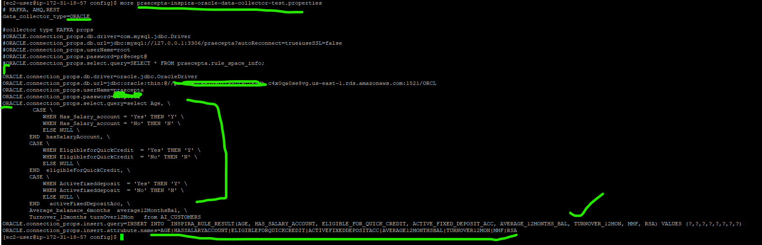

Rule Space and Rule Group Set Up Details
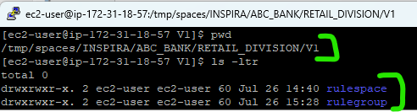
Rule Space Set Up Definition:
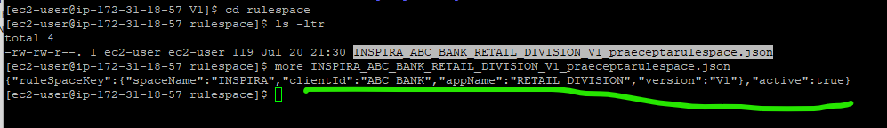
Rule Group Set Up Definition:
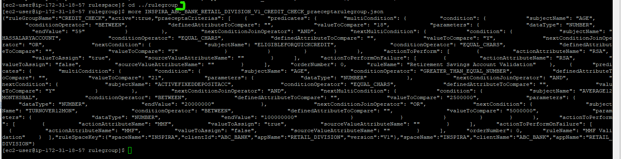

Triggering the Rule Execution By Passing the Execution Props and DB Connector Props
Before Rule Triggered:
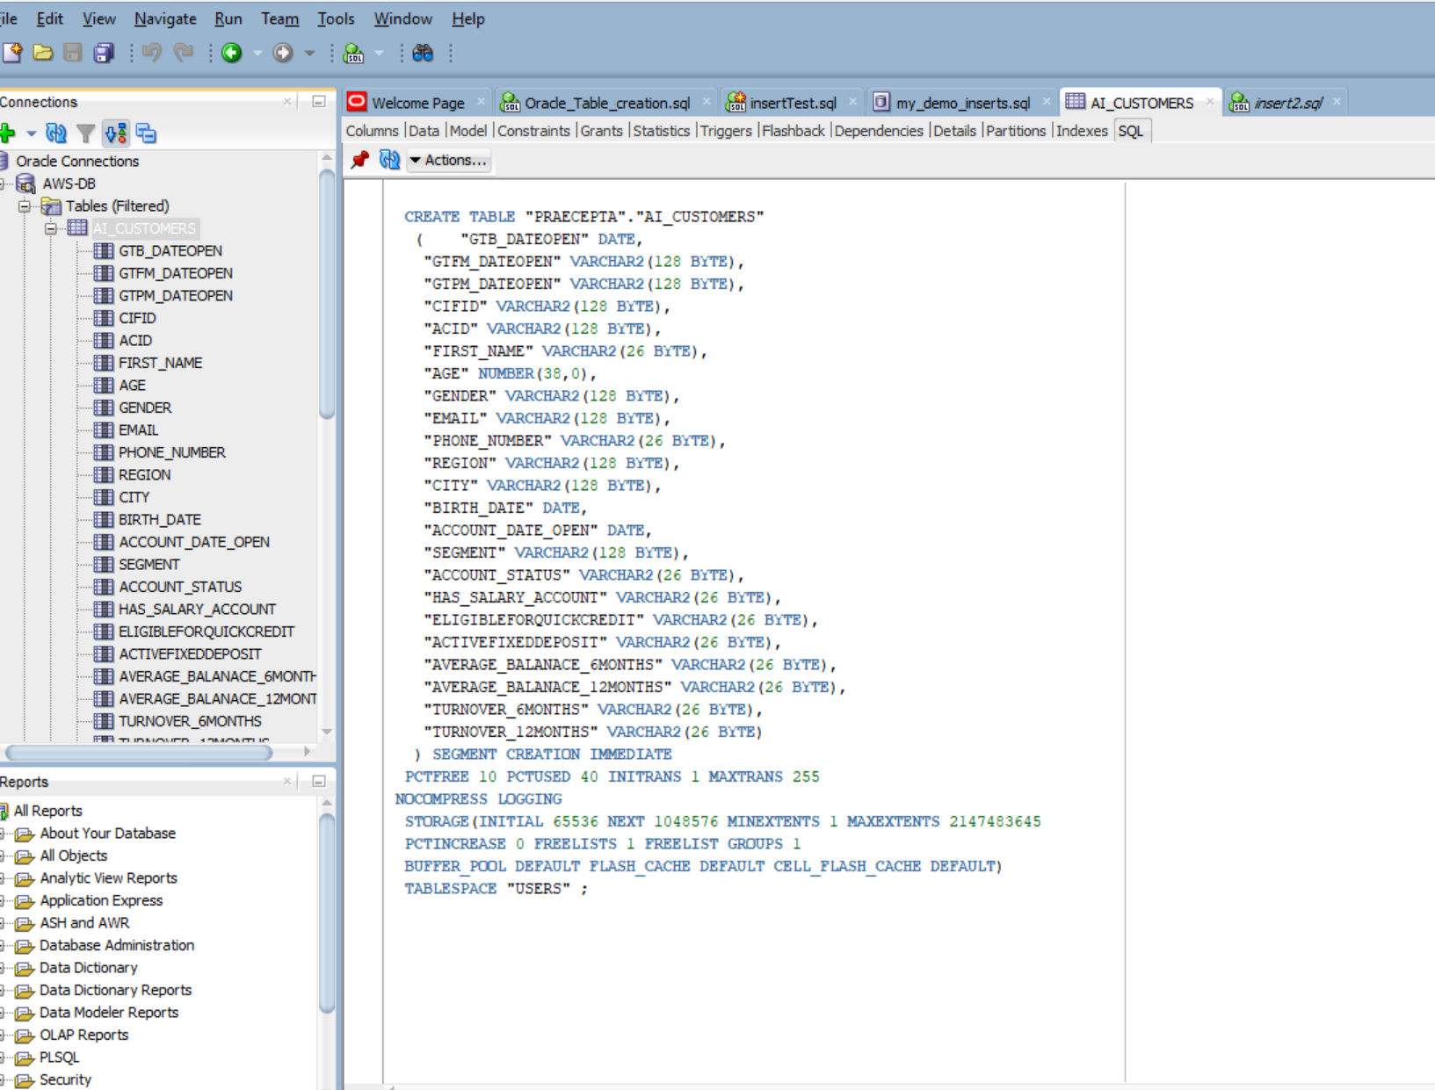
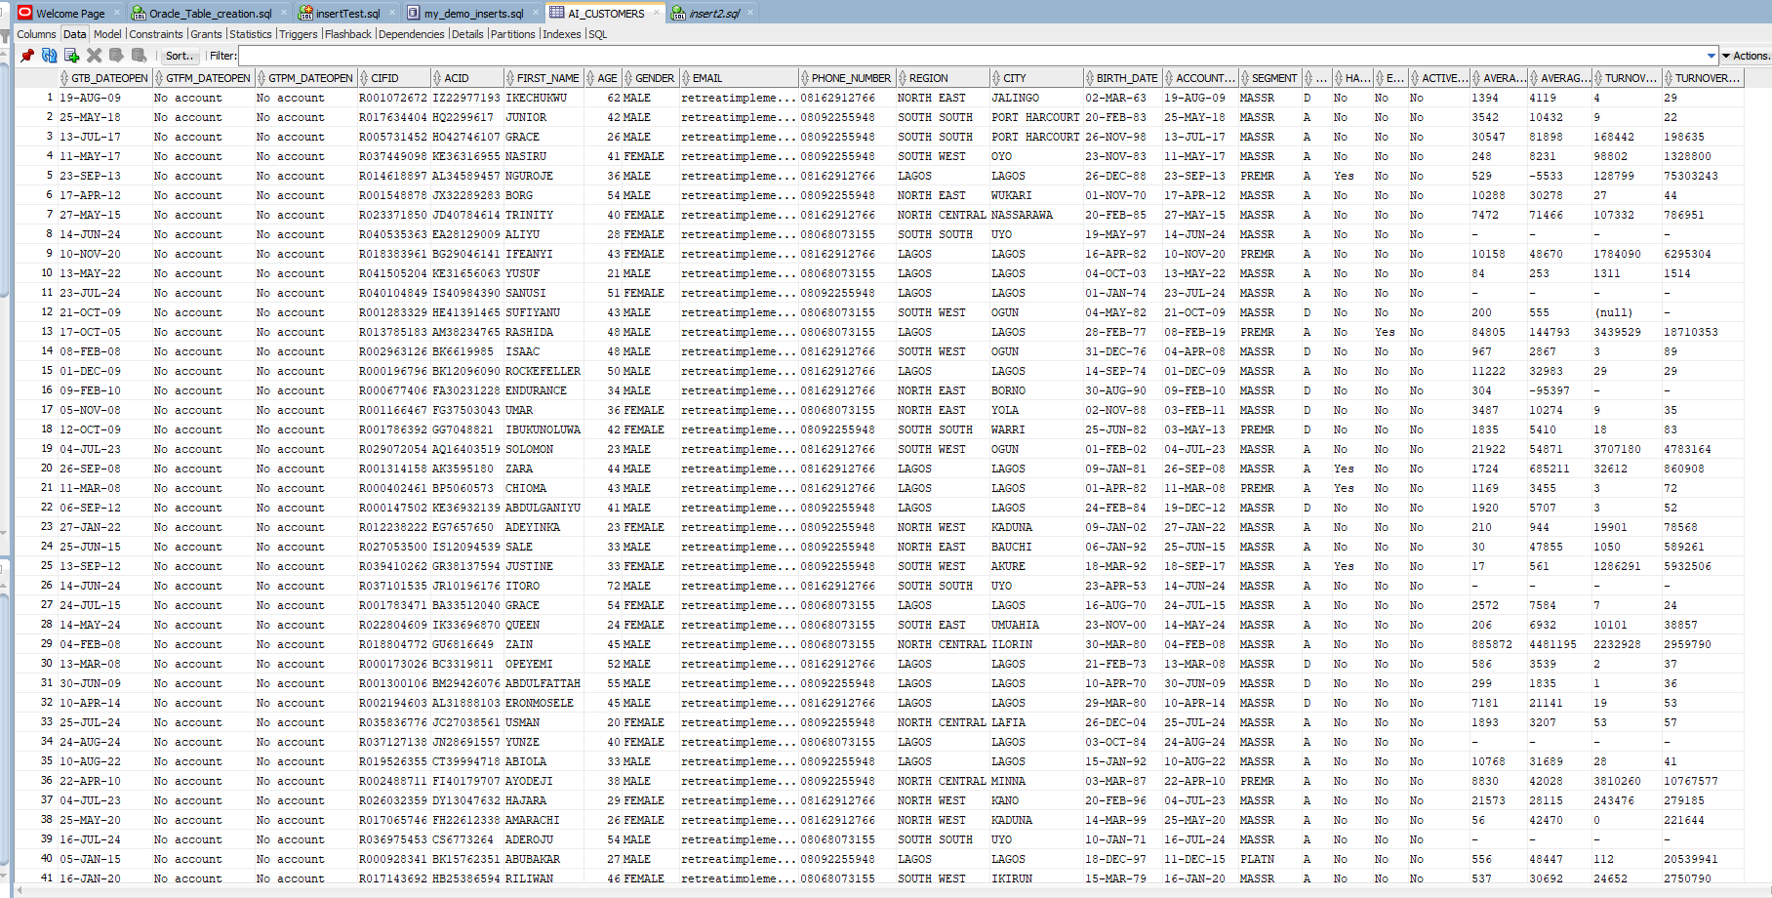
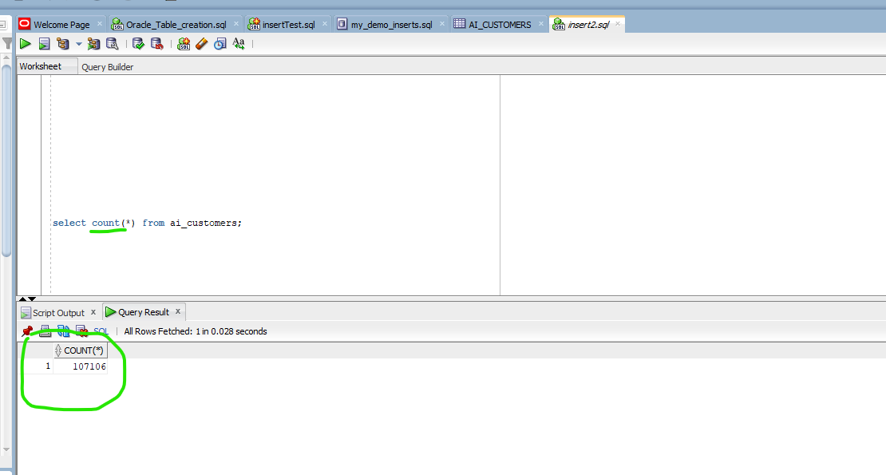
Rule Result Data with MMF and RSA before Rule triggered:
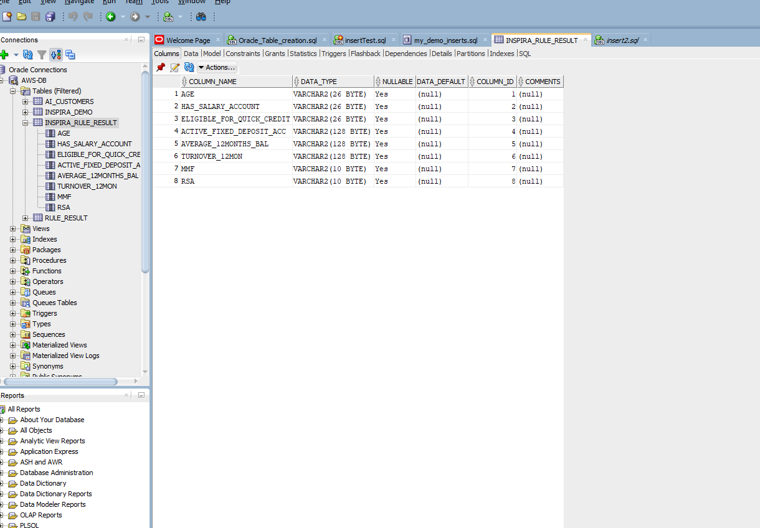
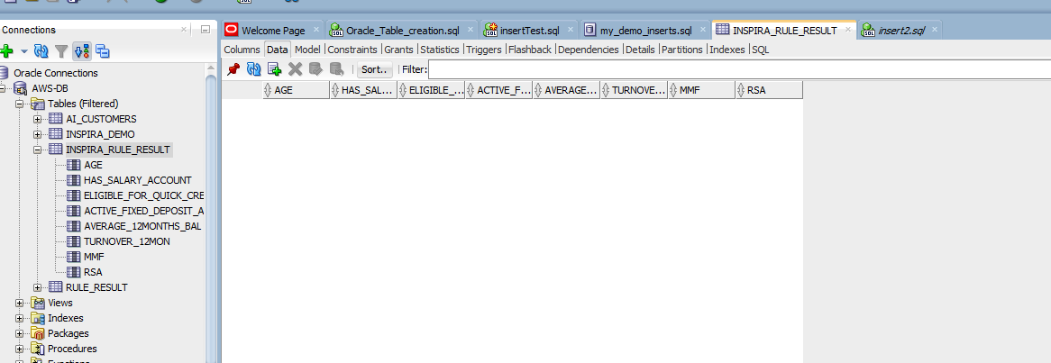
Count Before Execution triggered :
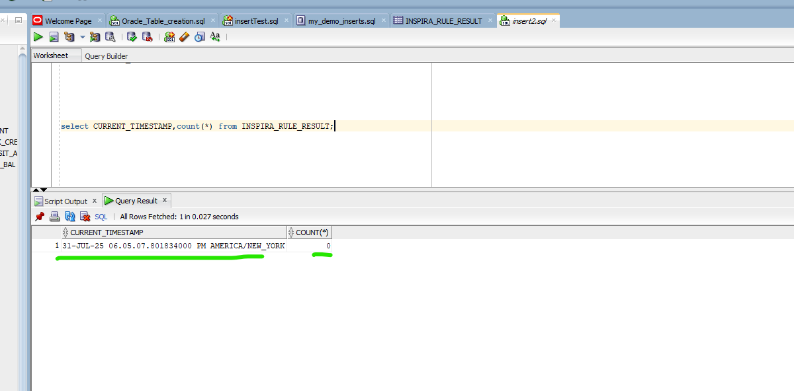

After Rule Triggered:
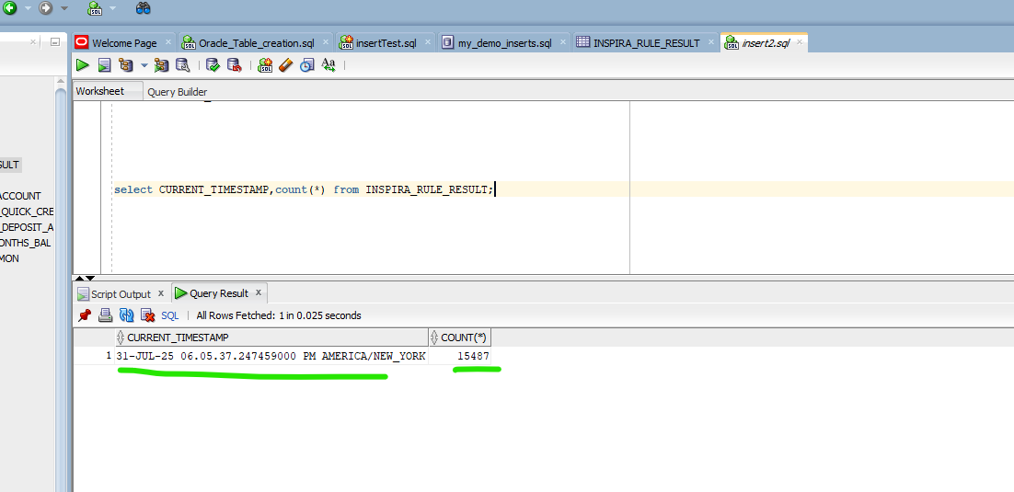
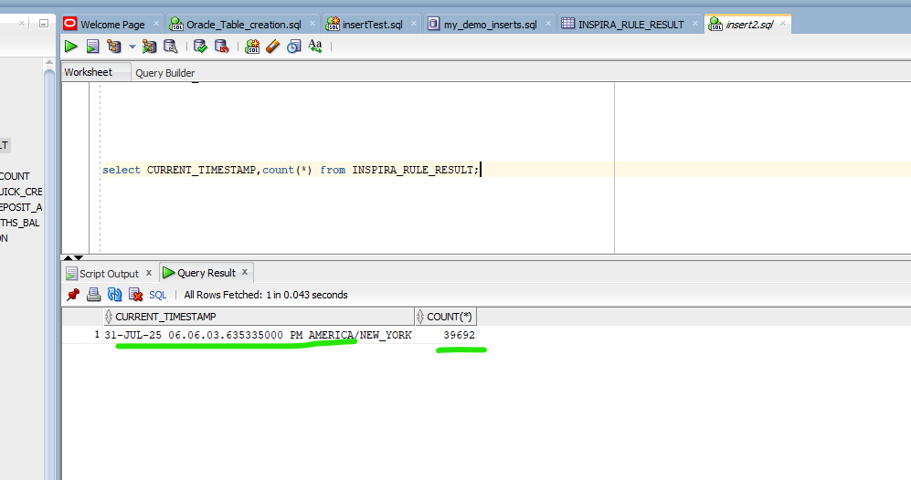
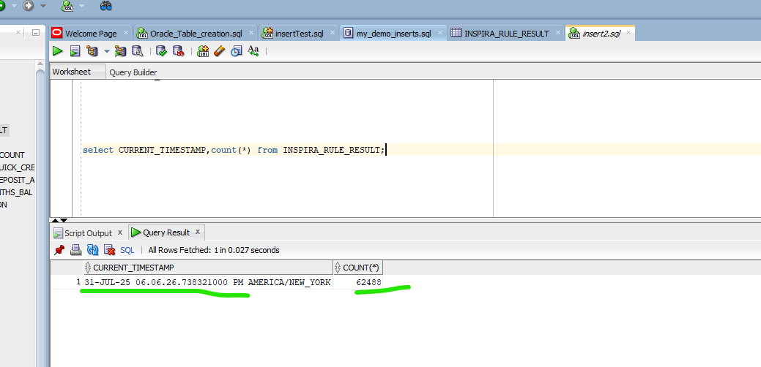
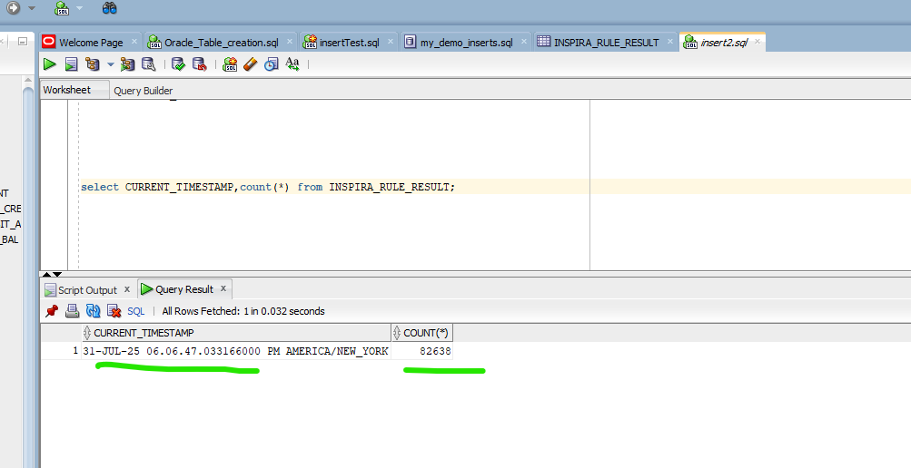
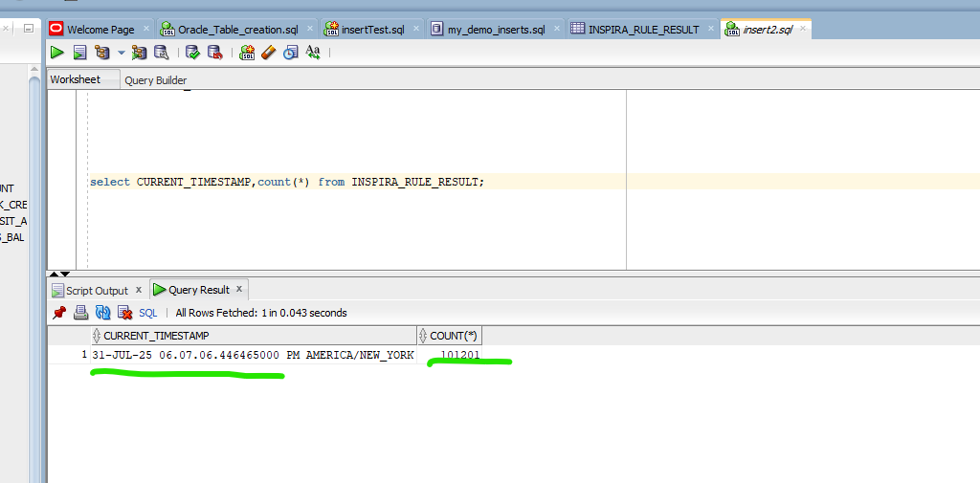
MMF Data After Rule Triggered:

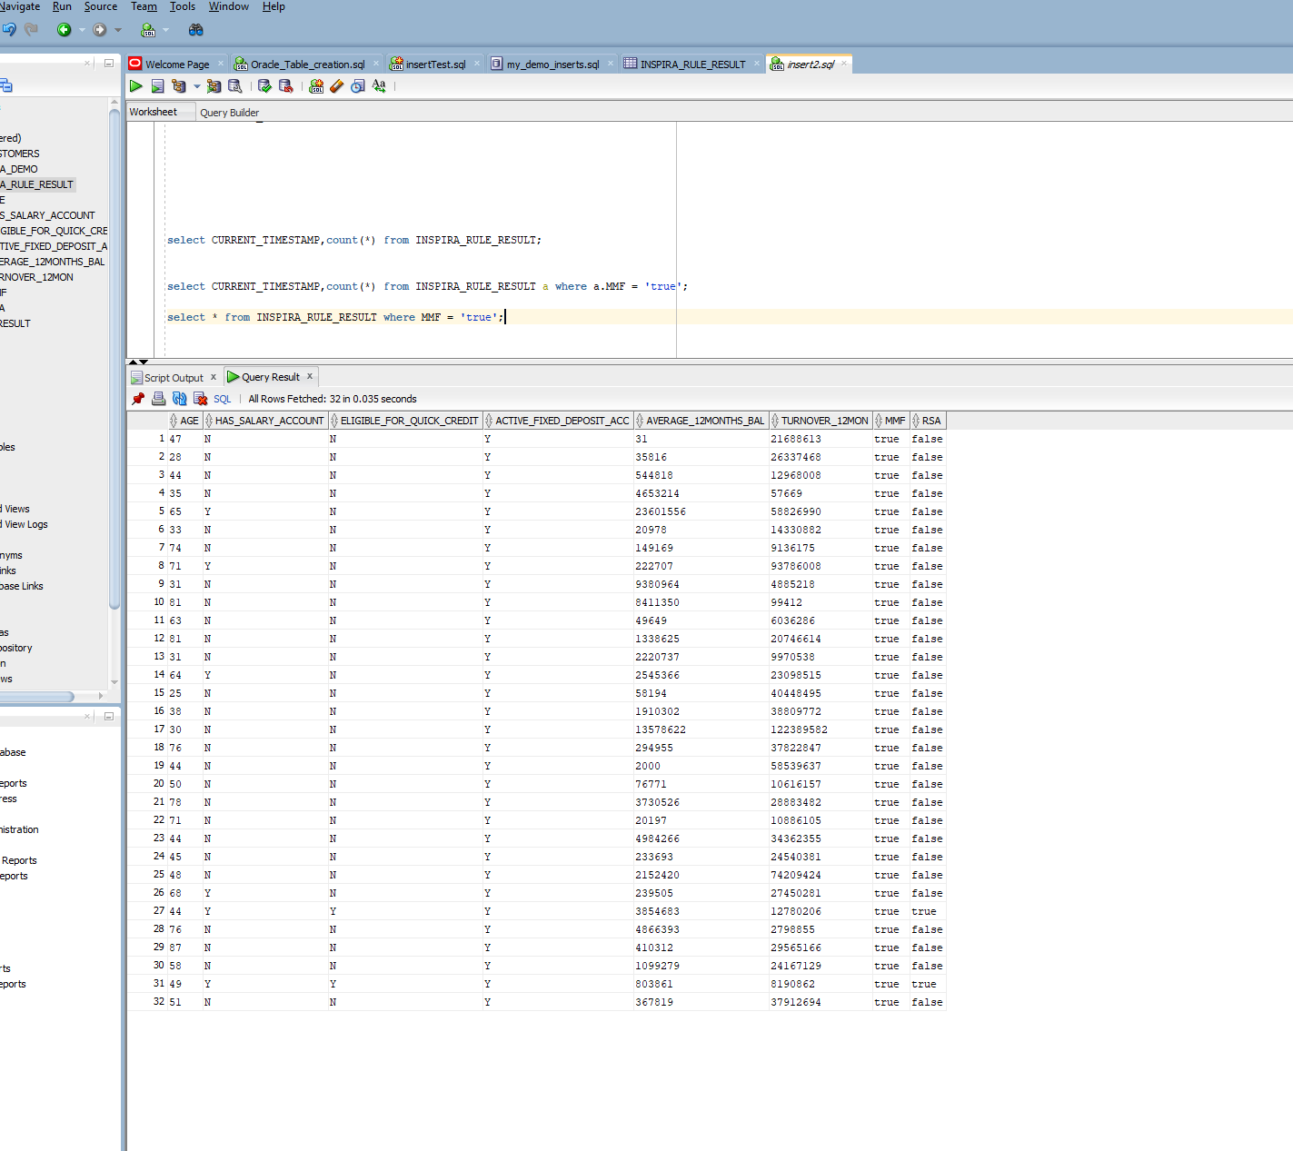
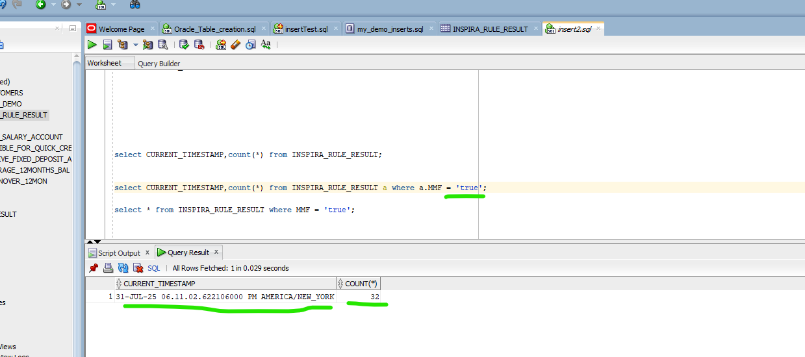

RSA Data After Rule trigger:


